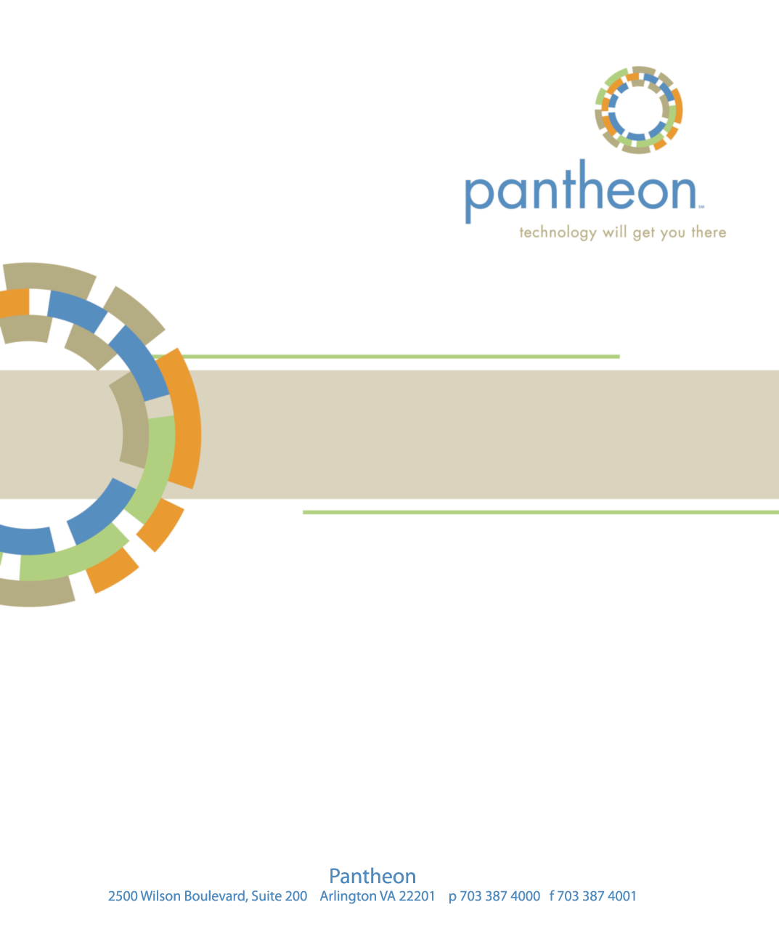
CAQH Website Redesign
CORE Training Workbook, April 8, 2015

CAQH Training Manual – CORE User Training

Creating your first page

Logging into Drupal

- Go to https://caqh.redesign.stg.lin.panth.com/user
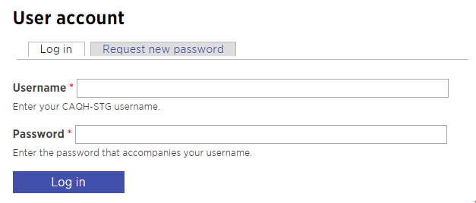
- Enter the credentials provided
- Select login
Once you have logged in the Drupal navigation bar will appear at the top of the page. We will explore this more during the rest of the training.

Adding content

The General Content Page

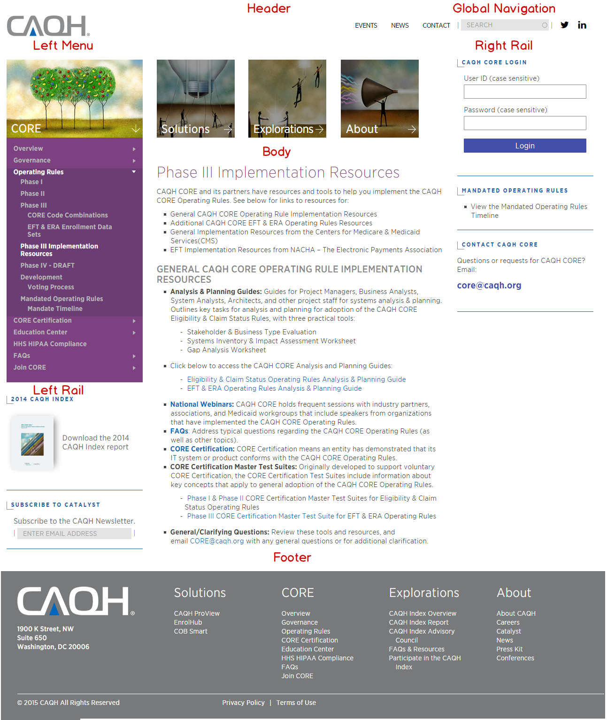

Exercise 1 - Create your first page

Preparation for the first exercise
- Open a new tab in your browser
- Go to http://prelaunch.caqh.org/about/core-training-page
We will use this page during the training to access resources that we will use throughout the training. So keep this page open.
- Use the link titled CORE Training Content Samples to download the word document that contains the content samples we will use during our training
- Keep the document open and return to Drupal
Use the Drupal Menu to navigate to Add content | CORE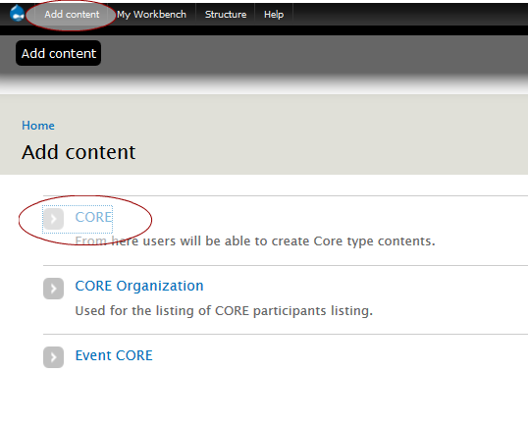

The content entry screen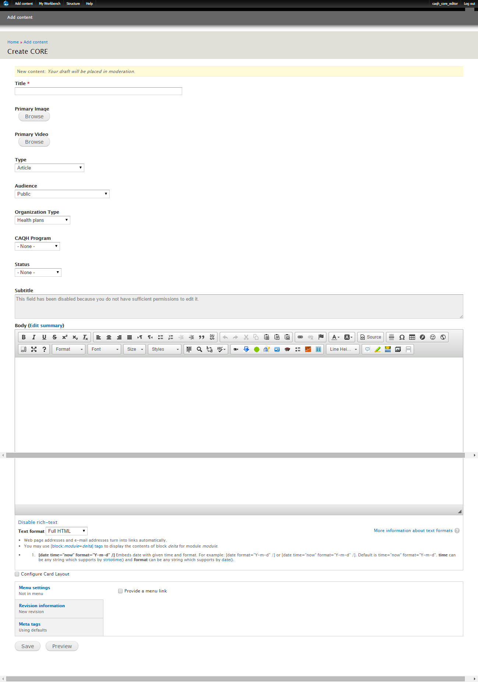

Fields in the Content Entry Screen
- Title – This is the title on the page. The field is required and text only
- Primary Image – Use this to associate a primary image with the page. Placement of the image is top left. This image will be used
- Primary Video – Use this to associate a primary video with the page. Placement of the video is the top of the page.
Taxonomy fields – The next 5 dropdowns are used to establish taxonomy for the page. This information may be used to classify the page for future enhancements.
- Type – This is the type of page or content you are creating (If you are unsure use Article)
- Audience – The target audience for this content
- Organization Type – If more than one then use none
- CAQH Program – References the internal program for this content
- Status – Currently used to classify the status of rules
- Subtitle – The subtitle of the page. You may use text formatting in this field.
- Body – This is the main body of content for the page. Place the content for the page here.
- Configure Card Layout checkbox – This will be used in a later training to setup cards that will be used on the section landing page for the CORE section.
- Menu settings – This will be used to include the page in the main menu
- Revision – Select this link to view information on the revision history of this document
- Meta tags – Select this tag to setup the content that will be used in the meta section of the head of the document. This is important for SEO and Social Media.

Create your first page
- Fill in the fields on the content entry screen
- For title use the title from the content sample. Prepend your title with your initials. This will make it easier for us to track the content created during the training
- For this exercise you may skip all the fields but the body field.
- For the body of the page copy the content from the sample and paste the content into the body field.
- When pasting content from other sources it is important remove any extra formatting that might be carried over. After you have pasted the content, highlight the text in the body field (place your cursor in the body field and press ctrl-a) then select the remove formatting icon from the menu bar at the top of the rich text editor used for the body field:
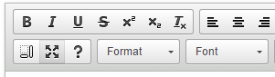
You should get in the habit of performing the extra step of removing formatting whenever you copy content form another source (word, emails, or the web).
- You are now ready to save your first page. Scroll to the bottom of the content entry page and select the Save button
- Once the save is complete, the page is rendered as it will appear on the site with two exceptions:
The content management tabs between the title and the content
And the moderation management at the bottom of the page

Exercise 2 – Use workflow to publish your page
CAQH uses a straightforward workflow for all pages on the site. There are three states:
- Draft
- Review
- Published
The typical workflow is to move from draft to review to published. When content is moved from one state to the next a notification will be sent to the appropriate individuals. (Note: Notifications are not currently active while the site is being setup.)
- Return to your workbench to see an overview of the pages in process. You should see the page you just created in the My edits window:
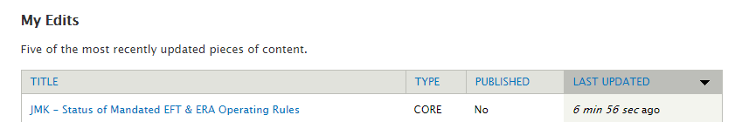
- Select the page you just created.
- Go to the bottom of the page to the moderation management section
- Use the dropdown to select the next state in the process. In this case we will follow the normal workflow and move the content to the Needs Review state.
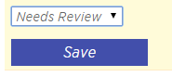
- At this point you should create a note. These notes will be part of the audit trail and can be used to remember the reason for creating the page and anything of note that happened during the creation and review process.
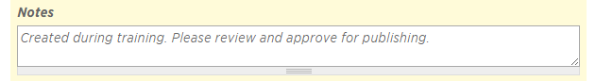
- Once you have created your note and selected the state, select Save to move the page to the next step in the workflow.
- The page will refresh. Scroll down to the moderation management section again. Note the change in the Revision State
- Review the page one last time and when you are satisfied that the content is correct return to the moderation management section and use the dropdown to select the Published state and select save again. Once a page is moved to the Published state it is visible. There is no delay.
- Return to your workbench. You will see that your page is now published:
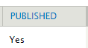

Alternate workflows
Each step in the workflow process includes alternatives. Here is a list of the alternative organized by state:
- Draft
  - Published – You may use this workflow step to move your page directly from the draft state to the published state. This will publish the page without review. It is always best practice to have someone else review your content before publishing
- Needs Review
  - Archive – Selecting this state will save the page but remove it from the content list. Use this when you have decided that you do not want to use this page.
  - Draft – Selecting this state will return the page to the draft state. The author of the content will be notified.
- Published
  - Actions: Unpublish this revision – Selecting this link will unpublish the page. The page will no longer be available to the public. You will be warned and asked to choose the state to return the page to. Use Draft is you wish to make changes to the page and then re-publish. Note: When a page is unpublished any link to that page will become dead links.
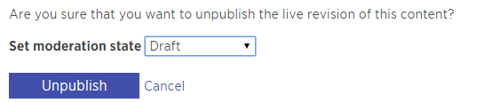

Exercise 2 – Edit an existing page
To make edits to a page after it has been created, create a new draft.
- Select your content page to return to the page.
- From the content management tabs select new draft
- Make changes, save and advance your content to the Published state.

Exercise 3 – Using the rich text editor in Drupal
In this exercise we will work with some of the formatting options available in the rich text editor.

Text formatting
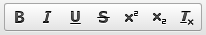
These icons represent the usual text formatting options. In order: Bold. Italics, Underline, Strikethrough, ^{Superscript}, _{Subscript}, and the one we have used previously, Remove Formatting.
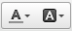
These icons are used to change the color of the text and the background color of the selected content.
Use this icon to insert a special character. For instance the Registered Trademark symbol: ®

Block commands
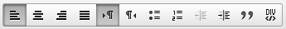
These icons are for applying formatting that will effect an entire block.
- The first four control the aligned of the text in the block (paragraph, div, etc.).
- The next two control the text direction if you will be using a language that reads from right to left.
- The next two are for creating unnumbered and numbered list.
- The next two are used to indent an entire paragraph or other block.
- The quotation mark icon is used to create a blockquote. The text of a blockquote will be indented on both margins and will be larger than the normal text.
- And the last icon in this group is used to wrap content in an html div. This is useful if you want to control a group of content as one block.

Undo, redo, cutting and pasting
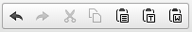
These icons are for undoing an action, redoing and action or cutting and pasting. The last two are for pasting as plain text or pasting from word. Sometimes when you copy content form another source and the content has complex formatting you may need to strip all the formatting form the content in order to avoid introducing errant styles onto your page. If the source is word use the Paste from word icon and if it is from another source you may need to use the Paste as plain text icon . Warning, using the paste as plain text will remove all formatting. Therefore you will lose links and other functionality. Generally the best process is to paste the content and then use the remove formatting icon .

Creating Links
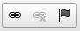
The web wouldn’t be the web without links. The next block of icons is for creating links.
Creating a link to another website
- Select the text in your content that you want to be a link. Select the link icon. The create link screen will open.
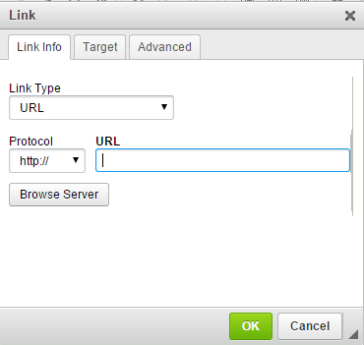
- Enter the URL in the text field provided. The URL should be of the form http://www.ncvhs.hhs.gov/ and the Protocol should be http://
- Select OK to return to the document.
Creating a link to another page on the CAQH website
When creating a link to another page on the CAQH website take the following steps:
- Open another tab and browse to the page you want to link to. I went to: http://caqh.redesign.stg.lin.panth.com/core/caqh-core-phase-iii-rules
- Copy the directory part of the URL excluding the domain: /core/caqh-core-phase-iii-rules
- Return to the create link screen in your other tab
- Change the protocol to <other> and paste the directory part of the URL into the URL text box.
- Select OK to return to the document.
Editing or removing a hyperlink
- To edit or remove a hyperlink start by placing your cursor anywhere in the link
- To remove the link select the remove link icon
- To edit the hyperlink select the hyperlink icon . The create link screen will open with the values for this link in the appropriate fields.
Creating an anchor on the page
For long or complex pages with many parts you may want to create an anchor in the page. An anchor allows you to create a link that will jump a user to that specific section of the page.
- Select the text you want to serve as the anchor
- Select the Anchor icon
- You will be prompted to provide a name for your anchor. Anchor names must be unique. Enter the name and select OK
Linking to an anchor
To link to an anchor in the text follow these steps:
- Select the text you want to serve as the anchor link
- select the hyperlink icon
- Use the Link Type dropdown to choose Link to anchor in the text. Use the By Anchor Name dropdown to select the previously created anchor.
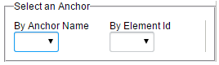
- Select OK.
Linking to an Anchor on another page
To link to an anchor on another page follow the process to create a link. At the end of the link add a hash tag and the name of the anchor. Example: /core/test#OtherPageAnchor

View source
CK Editor, the editor used by Drupal, uses HTML to format the text. From time to time you may find that the text requires adjustments that you cannot do using the controls or you may want to do something that is not possible within CK Editor. In those cases you may use the View source button to directly manage the HTML. It is recommended that you avoid modifying the source unless you have no choice.

Alternate List Styling
In addition to the standard bulleted and numbered list there are two other features that you may want to use.
Accordions
An accordion is used for long lists of content. Each section of content has a header and body. The body is hidden until the user select the header to reveal the content. An example of the use of accordions may be found on the following page:
http://caqh.redesign.stg.lin.panth.com/core/ongoing-maintenance-core-code-combinations-caqh-core-360-rule
- To create an accordion, select the accordion icon.
- Enter the number of accordion section you would like. You can always delete sections after the accordion is created so it is easiest to create more than you will need and then remove the unused section at the end.
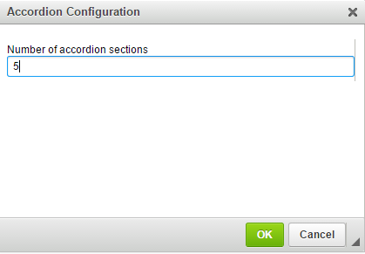
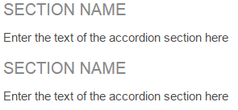
- The above text will appear in the body. Replace the Section Name with the section header and Enter the text of the accordion section here with the body for that accordion section.
Long list text format
CAQH has a number of lists that contain a significant amount of text in each bullet. To accommodate this a separate style was established that adds more space between the list items. To use this alternate list style select the above icon which appears next to the accordion icon.
Enter the list text as normal.
Adjusting line height
You may want to change the line height used by default. To do so, highlight the list or paragraph. Select the Line Height icon and choose the height adjustment you would like.

Callouts
Within the body of a large section of text it is often important to highlight a line of text, quote or other notable phrase. To do this use the call out.
- To create a callout select the Call Out icon
- You will be prompted to choose whether you want the callout to align right or left. Select the side you want the callout to align with.
- Select OK.
- A callout will appear on you page. Replace the text in the callout with your own text.
- If you want to move or delete the callout you will need to directly edit the source of the document.

Exercise 4 – Using the Media Center
The media center is used to manage binary assets. Examples include images, audio files, PDFs, and Office documents like word or excel.

Upload a file
- Select the Media Center icon
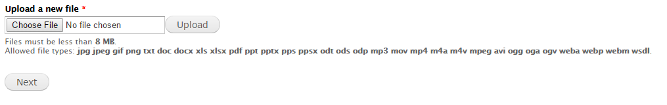
- The upload screen will appear. Select Choose File and select a file to upload.
- When the name of the file appears in the Choose File text field select Next.
- The next screen is used to enter information to describe the document. It is important to fill in this information.
  - Name – This is the name of the file that will be used by the system. Avoid spaces punctuation and special characters.
  - Alt Text – This is the alt text which will appear when a user hovers over a link created using this file.
  - Title Text – This is the title of the document. When inserting the file into a page the title will automatically be used as the text of the link.
  - Description – Enter a short description of the document. This will be used for SEO and indexing.
- Select Submit. The document will appear as a link on your page. The text of the link will be the Title you entered for the document.

Add a YouTube Video
- Select the Media Center icon
- Select the YOUTUBE tab
- Enter a search term to find the video that you would like to include and press enter. I used CAQH. Drupal performs a search of YouTube and returns the results:
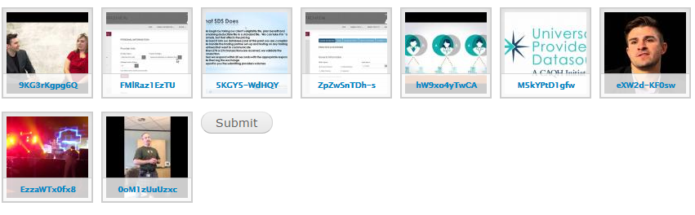
- Select the video that you want to add to the page and then select Submit.
- You are then prompted to select from different display options:
  - Teaser
  - Preview
  - Link
  - Original
  - WYSIWYG
- Experiment with these options to find the one that works best for your purposes.

Images
The process for adding an image is similar to the process for adding a file.
- Place your cursor in the document where you want the image to appear.
- Select the Media Center icon
- Upload the image
- Select Next
- Enter the appropriate Name, Alt text, Title, and description
- Select Submit
- You will be presented with a preview of the image. Scroll down and select Submit to place on the page.

Searching the library
The media center provides different options for search for images or files that have been previously uploaded.
My Files
The My Files tab displays a list of files that you have uploaded to the center. In addition you can search by several different factors:
Once you have selected your search criteria select apply to refine the list.
Library
To search for a file anywhere in the Media Center select the Library tab
Here too you can search by different factors to find a specific asset. You can search by:
- File name – the name of the file that was uploaded
- Image title – the title you entered for the image
- Document title – the title of a document
- Type – Use this dropdown to select the type of asset to search for.

The file browser
In addition the files managed through the media center, CAQH had a number of files stored on its server which were ported over to the new site. To access these files you will use the File Browser.
- Select the link icon
- Select Browse Server
- A file browser will open in another window. Use this to find and select a file:
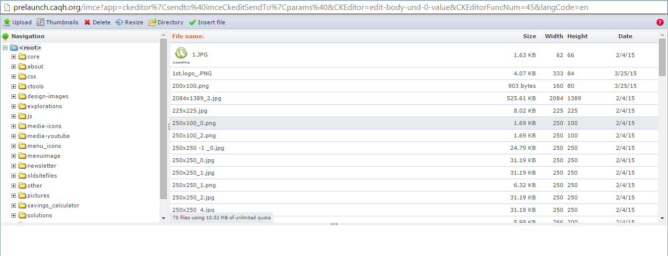
Considerable work was done to reorganize the file structure to make it easier to use and understand. The repository is now organized by section and within section by topics. You will use the CORE section.
- Once you have selected the file that you want to link to select Insert File to place a link to this file in the Link creation window.
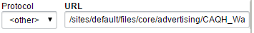
You may now place the link on the page as you would any other link.

Tables
- Select the table icon to insert a table on your page
- The table properties window will appear
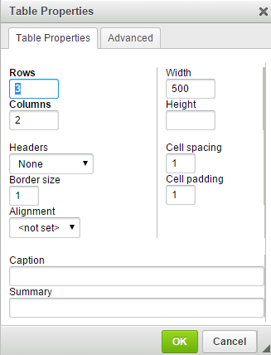
- Set the following properties:
  - Rows – Enter the number of rows for your table
  - Columns – Enter the number of columns for your table
  - Headers – This dropdown allows you to specify whether the first row and/or the first column should be treated as a header. Header columns and rows display the labels for the corresponding rows and columns.
  - Alignment – Use this to set the alignment of the entire table (Right, Left, Center)
- Once you have completed setting your options select OK to place the table on the page.
- The table styles have been set site wide to provide minimize clutter and improve usability
- Click inside the table to begin entering data. You may use the tab key to quickly move to the next column and row.

