ASCII Sample of Updated Gender Limitations Mapping
- The value “Not Applicable” will display in extracts for providers who answer “No” to, “Do you have gender limitations?” and for providers who answer “Yes” to “Do you have gender limitations?” and select “None” or “N/A” to “Gender Limitation Type”.
40411275|1000|1000|0||||||Not Applicable
- The value “Female Only” will display in extracts for providers who answer “Yes” to “Do you have gender limitations?” and select “Female Only” from “Gender Limitation Type”.
40411275|1000|1002|0||||||Female Only
- The value “Male Only” will display in extracts for providers who answer “Yes” to “Do you have gender limitations?” and select “Male Only” for “Gender Limitation Type”.
40411275|1000|1004|0||||||Male Only

XML Sample of Updated Gender Limitations Mapping
- The value “Not Applicable” will display in extracts for providers who answer “No” to, “Do you have gender limitations?” and for providers who answer “Yes” to “Do you have gender limitations?” and select “None” or “N/A” to “Gender Limitation Type”.
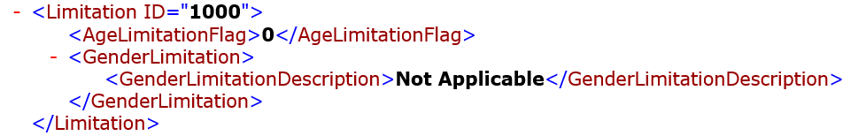
- The value “Female Only” will display in extracts for providers who answer “Yes” to “Do you have gender limitations?” and select “Female Only” from “Gender Limitation Type”.
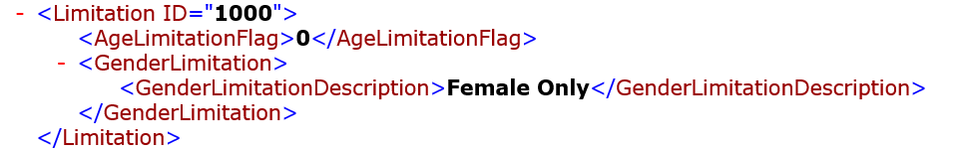
- The value “Male Only” will display in extracts for providers who answer “Yes” to “Do you have gender limitations?” and select “Male Only” for “Gender Limitation Type”.
